**Homework 7**

5.3. You have been asked to develop a system that will help with planning large-scale events and parties such as weddings, graduation celebrations, and birthday parties. Using an activity diagram, model the process context for such a system that shows the activities involved in planning a party (booking a venue, organizing invitations, etc.) and the system elements that might be used at each stage

5.5. Develop a sequence diagram showing the interactions involved when a student registers for a course in a university. Courses may have limited enrollment, so the registration process must include checks that places are available. Assume that the student accesses an electronic course catalog to find out about available courses.

5.7. Based on your experience with a bank ATM, draw an activity diagram that models the data processing involved when a customer withdraws cash from the machine.

5.8. Draw a sequence diagram for the same system. Explain why you might want to develop both activity and sequence diagrams when modeling the behavior of a system.

6.4. Draw diagrams showing a conceptual view and a process view of the architectures of the following systems:

* A ticket machine used by passengers at a railway station.

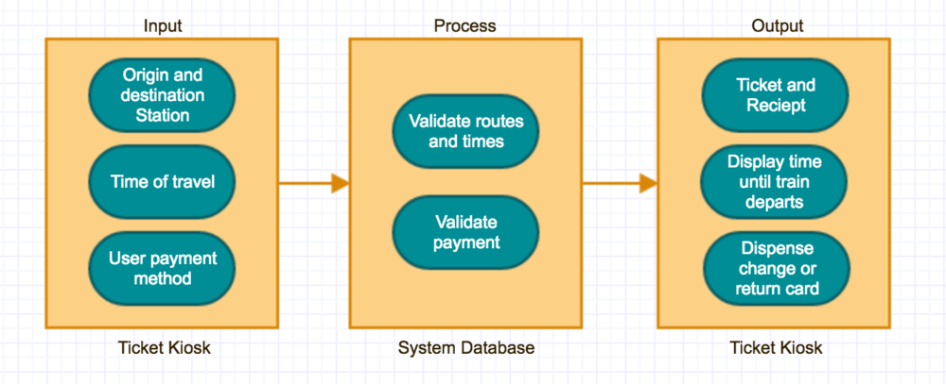

* A computer-controlled video conferencing system that allows video, audio, and computer data to be visible to several participants at the same time.

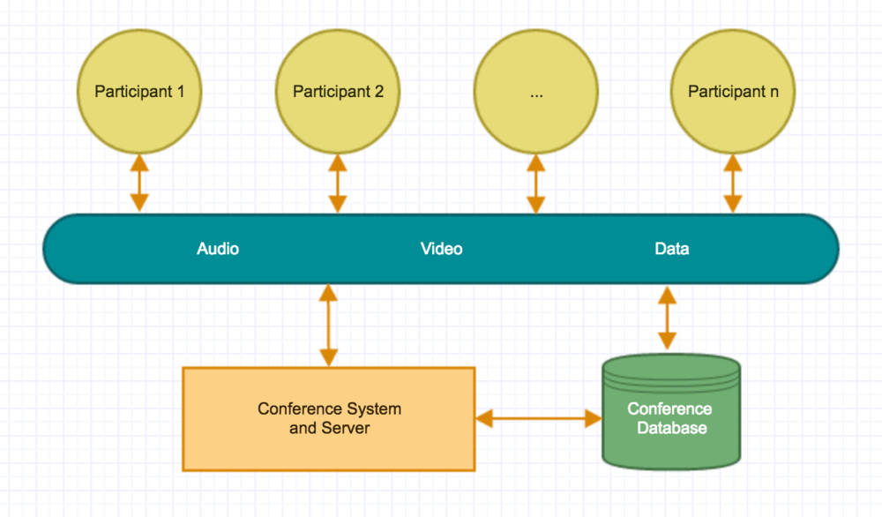

* A robot floor-cleaner that is intended to clean relatively clear spaces such as corridors. The cleaner must be able to sense walls and other obstructions.

